Particular | Details
Department | Computer Science and Engineering (Artificial Intelligence)
Programme | B.Tech – CSE (AI)
Course Code & Course Name | CSA1610 – Data Warehousing and Data Mining
Academic Year / Batch | 2025 – 2029
Faculty Name | Dr.K V Kanimozhi
Assignment Title | Design and Development of an Integrated DataWarehouse and Data Mining System for Banking Transaction Analysis and Fraud Classification
Date of Issue | 31-8-2026
Date of Submission | 2-8-2026
Maximum Marks | 100
Course Outcome(s) – CO | CO1, CO2, CO3
Bloom's Taxonomy Level | L3 – Apply; L4 – Analyze; L5 – Evaluate; L6 – Create
SDG Mapping | SDG 8, SDG 9, SDG 12
Industry / Societal Relevance | Retail analytics, customer relationship management, and data-driven retention strategy in e-commerce

Problem Statement

Modern banking institutions generate enormous amounts of data from multiple operational systems, including customer accounts, deposits, withdrawals, fund transfers, ATM transactions, online banking, card payments, branch operations and transaction monitoring systems. Since these systems may have been developed independently for different operational purposes, banking data is often distributed across different databases and files and may contain inconsistent formats, duplicate records, missing values and varying transaction codes.The fragmented nature of banking data makes it difficult for management and fraud-monitoring teams to obtain a unified view of customer transaction behaviour. Traditional transaction-monitoring methods may also struggle to identify complex and rapidly changing fraudulent patterns, particularly when the number of legitimate transactions is significantly higher than the number of fraudulent transactions.The issue addressed by this assignment has two major aspects. First, an integrated Data Warehouse must be designed and developed to combine customer, account, transaction, branch and payment information into a centralized analytical repository. This warehouse should support multidimensional OLAP analysis of transaction amounts, transaction types, customers, branches and time periods.Second, suitable Data Mining classification techniques must be developed and evaluated to classify banking transactions as either legitimate or fraudulent. The system should identify suspicious transaction patterns and provide useful information that can support fraud investigators and banking management in making timely decisions.

Objective

1.To integrate customer, account, transaction, branch, card and payment-related data from multiple banking sources into a centralized Data Warehouse.

To design a Star Schema with appropriate dimension tables for efficient banking transaction analysis.

To develop an ETL (Extract – Transform – Load) pipeline for extracting, cleaning, transforming and loading banking data into the warehouse.

To apply preprocessing techniques such as missing-value handling, duplicate removal, data integration, normalization, transformation and feature selection.

To perform OLAP operations such as roll-up, drill-down, slice, dice and pivot to analyse banking transactions from different perspectives.

To identify important transaction patterns such as high-value transactions, unusual transaction frequencies, transaction-type distributions and branch-wise transaction behaviour.

To develop classification models for identifying whether a banking transaction is Fraudulent or Legitimate.

To develop and compare Decision Tree, Naïve Bayes and Support Vector Machine (SVM) classification models for fraud detection.

To evaluate the classification models using Accuracy, Precision, Recall, F1-score and Confusion Matrix.

To identify the most suitable classification model for banking fraud detection based on predictive performance and practical considerations.

To provide actionable recommendations for improving fraud monitoring and banking transaction security.

To consider privacy, security, fairness and ethical issues associated with analysing customer financial transaction data.

3. Requirements and Environment Used

3.1 Functional Requirements

• Integrate customer information, account information, transaction records, branch details, card/payment information and transaction channels into a single Data Warehouse.

Store historical banking transactions in a structured format suitable for analytical processing..

Support analytical queries based on customer, account, transaction type, branch and time.

Identify transaction characteristics such as transaction amount, transaction frequency, transaction channel and transaction location.

3.2 Non-Functional Requirements and Constraints
- Performance: OLAP queries on the transaction fact table should provide results within interactive time for the sample dataset used in the coursework
- Technical constraint: Banking information may originate from heterogeneous sources such as relational databases, CSV files, Excel files and transaction logs. These sources must be converted into common formats.
- Data quality constraint: Missing values, duplicate customer/account records, inconsistent transaction types and invalid transaction amounts must be identified and resolved before warehouse loading.
- Privacy/security: Personally identifiable information such as customer names, account numbers, phone numbers and card details must be masked, encrypted or pseudonymised before being used for data mining.
- Scalability: The warehouse design should support expansion from a coursework-scale dataset to larger banking transaction volumes without requiring a complete schema redesign.
- Time and resource constraint: the assignment is completed using open-source, freely available tools within the course timeline.

3.3 Environment / Tools Used
Purpose | Tool / Technology
Data warehouse design & schema modelling | Star/Snowflake schema modelling (draw.io / dbdiagram.io)
ETL pipeline | Python (pandas) scripts and KNIME ETL nodes
Preprocessing | Python (pandas, scikit-learn), KNIME preprocessing nodes
OLAP analysis | KNIME Pivoting, Excel Pivot Tables and SQL GROUP BY/CUBE
Classification and mining | Weka 3.8 and KNIME Analytics Platform (Decision Tree, Naïve Bayes, SMO/SVM)
Evaluation | 10-fold cross-validation, Confusion Matrix, Accuracy, Precision, Recall, F1-score
Documentation | MS Word, screenshots from KNIME/Weka workflow

4. Problem Understanding and Formulation

4.1 What is the Problem?
Banking transaction data is distributed across several functional systems, including customer management, account management, transaction processing, card services, ATM systems, online banking and branch systems.
These systems contain large volumes of transaction records, but the data cannot always be directly used for integrated analysis because of different data formats, identifiers and structures.

4.2 Expected Outcomes
- A validated Star/Snowflake Data Warehouse schema with a central FACT_TRANSACTIONS table.Dimension tables for Customer, Account, Time, Branch, Transaction Type and Channel. A working ETL pipeline following the process:
Extract → Clean → Transform → Load
- Cleaned and integrated banking transaction data.
- OLAP analysis identifying:
- Monthly transaction trends
- High-value transactions
- Branch-wise transaction performance
- Transaction-type distribution
- Fraud distribution
- Channel-wise fraud behaviour
- Three trained fraud-classification models:
- Decision Tree
- Naïve Bayes
- SVM
- Performance comparison using:
- Accuracy
- Precision
- Recall
- F1-score
- Confusion Matrix
- Three trained and evaluated churn-classification models with a justified best-model recommendation.
- A short set of evidence-based customer-retention recommendations.

4.3 Available Data / Information
The assignment assumes access to five operational sources typical of an e-commerce business: (1) a Customers table (customer ID, demographics, signup date, region), (2) an Orders/Transactions table (order ID, customer ID, product ID, order date, quantity, amount, order status), (3) a Products table (product ID, category, sub-category, price, supplier), (4) a Payments table (payment ID, order ID, payment mode, payment status) and (5) a Website-Interaction log (session ID, customer ID, page views, time-on-site, cart-abandonment events, last-login date). Since raw production data could not be sourced for coursework use, a representative synthetic dataset with the same schema, realistic value distributions and comparable data-quality issues (missing values, duplicates, inconsistent formats) is used to illustrate the design and mining workflow throughout this report.

4.4 Assumptions

A transaction is labelled Fraud when historical investigation or the supplied dataset identifies it as fraudulent.

Transactions without confirmed fraud indicators are labelled Legitimate.

Customer and account identifiers are assumed to be unique after data cleaning.

All transaction amounts are assumed to be recorded in a common currency.

Personally identifiable and sensitive financial information is anonymised or pseudonymised before mining.

The dataset is assumed to contain sufficient legitimate and fraudulent transactions for classification.

The historical transaction dataset is assumed to represent the general behaviour of the banking environment for coursework purposes.

Actual production deployment would require validation using real historical banking data and continuous model monitoring.

4.5 Constraints to be Satisfied
- The Data Warehouse schema must support the required OLAP operations without requiring structural changes.
- The ETL process must maintain consistency between customer, account and transaction records.
- Data preprocessing must avoid target leakage, particularly where the fraud label could unintentionally become a predictor.
- At least three classification algorithms must be trained and evaluated.
- Fraud detection should consider the highly imbalanced nature of banking transaction datasets.
- Model performance should be evaluated using multiple metrics rather than accuracy alone.
- Customer financial information must be protected throughout the data-processing pipeline.
- The final system should provide useful and interpretable analytical results.

5. Application of Course Knowledge

5.1 Data Warehousing Concepts Applied
- Dimensional modelling (Kimball approach): identification of grain, facts and dimensions for the Star Schema.
- FACT_TRANSACTIONS stores transaction-level measures such as transaction amount, transaction count and balance.Star Schema.
- A central transaction fact table is connected to Customer, Account, Time, Branch, Transaction Type and Channel dimensions.Snowflake Extension:
- Slowly Changing Dimension (SCD Type 1 for corrections, Type 2 for tracked history) reasoning applied to the Customer dimension so address/segment changes over time can optionally be preserved.

5.2 ETL and Preprocessing Concepts Applied
- Extract – Transform – Load pipeline staging: raw → staging → cleaned → warehouse.
- Data cleaning: handling of missing values (mean/median/mode imputation, listwise deletion where appropriate), duplicate-record elimination via customer-key matching, and outlier detection using the IQR rule.
- Data integration: schema/entity matching across sources using surrogate keys, and resolution of naming/unit inconsistencies.
- Data transformation: normalisation (min–max scaling) of numeric attributes such as order amount and session duration for distance-based algorithms; discretisation of continuous “recency/frequency/monetary” values into categorical bins for interpretability.
- Data reduction: dimensionality reduction by dropping attributes with near-zero variance or high correlation, and aggregation of interaction-log rows into per-customer engagement summaries (RFM-style features).

5.3 Data Mining / Classification Concepts Applied
- Decision Tree induction (ID3/C4.5-style, information gain / gain ratio splitting criterion, entropy-based impurity).
- Naïve Bayes classification based on Bayes' theorem with the (conditional) independence assumption among predictors.
- Support Vector Machine (SVM) classification using a maximum-margin hyperplane, with an RBF kernel considered for non-linear separability.
- Model evaluation theory: Confusion Matrix, Accuracy, Precision, Recall, F1-score, and k-fold Cross-Validation for robust performance estimation.

6. Design / Proposed Solution

6.1 Data Sources and ETL Pipeline Design
The proposed system uses multiple banking data sources and processes them through a four-stage ETL pipeline: (1) Extract – raw extracts are pulled from the Customers, Orders, Products, Payments and Interactions sources on a nightly batch schedule; (2) Clean – missing-value imputation, duplicate removal and format standardisation are applied in a staging area; (3) Transform – surrogate keys are generated, measures are derived (e.g. order amount = quantity × unit price − discount), and RFM engagement features are computed per customer; (4) Load – the cleaned, transformed records are loaded into the Sales Fact table and its associated dimension tables using a surrogate-key lookup so that the warehouse remains insulated from operational-system key changes.
ETL Stage Summary
Stage | Key Activities | Output
Extract | Customer database, Account database, Transaction database, ranch database, Card/payment system. | Raw staging tables
Clean | Handling missing values, Removing duplicate records, Correcting invalid transaction amounts, Standardizing transaction types. | Cleaned staging tables
Transform | Generate surrogate keys, derive measures, compute RFM features, discretise attributes | Conformed fact/dimension records
Load | FACT_TRANSACTIONS, DIM_CUSTOMER, DIM_ACCOUNT, DIM_TIME. | Populated Data Warehouse

6.2 Data Preprocessing Applied
Technique | Applied To | Justification
Missing-value imputation | Customer age, order amount, delivery duration | Median/mode imputation preserves distribution shape better than deletion on a small coursework sample
Missing-value imputation | Age, account balance, transaction attributes | Prevents double-counting of customers in OLAP aggregates and mining
Duplicate removal | Customer and transaction records | Prevents double-counting
Normalisation (min-max) | Order amount, session duration, page views | Puts numeric predictors on a comparable scale, required for SVM and improves Naïve Bayes stability
Class balancing | Fraud vs Legitimate transactions | Reduces the effect of severe class imbalance
Feature engineering | Transaction frequency, velocity and location changes | Improves fraud-detection capability

6.3 Data Warehouse Schema – Star / Snowflake Design
A Star Schema is adopted for its query simplicity and performance, with the Product dimension snowflaked into Category/Sub-category to avoid redundant text storage given the large product catalogue. The grain of the fact table is one row per order line item.
Fact Table: FACT_SALES
Column | Type | Role
Transaction_Key | Surrogate Int | Primary Key
Customer_Key (FK) | Int | Foreign Key
Account_Key | Int | Foreign Key
Time_Key (FK) | Int | Foreign Key
Payment_Key (FK) | Int | Foreign Key
Region_Key (FK) | Int | Foreign Key
Quantity | Numeric (Measure) | Additive measure
Unit_Price | Numeric (Measure) | Measure
Discount_Amount | Categorical | Transaction status
Sales_Amount | Categorical | Additive measure
Order_Status | Categorical | Fraud / Legitimate
Dimension Tables
Dimension | Key Attributes | Notes
DIM_CUSTOMER | Customer_Key, Customer_ID, Age_Band, Gender, Signup_Date, Customer_Segment | SCD Type 2 optional for Segment history
DIM_PRODUCT | Product_Key, Product_Name, Sub_Category_Key → Category | Snowflaked into Category / Sub-category
DIM_TIME | Time_Key, Date, Month, Quarter, Year, Is_Season_Peak | Enables roll-up from Day → Month → Quarter → Year
DIM_PAYMENT | Payment_Key, Payment_Mode, Payment_Status | Card / UPI / Wallet / COD
DIM_REGION | Region_Key, City, State, Zone | Enables roll-up City → State → Zone
This design directly supports the required OLAP operations: Roll-up/Drill-down along DIM_TIME (Day→Month→Quarter→Year) and DIM_REGION (City→State→Zone); Slice on a single dimension member (e.g. Region = “South Zone”); Dice on multiple dimension members simultaneously (e.g. Category = “Electronics” AND Quarter = “Q4”); and Pivot to re-orient the Customer × Product cross-tabulation for segment analysis.

7. Algorithm / Pseudocode

7.1 ETL Pseudocode
FOR each source in {Customers, Accounts, Transactions, Branches, Payments}:
EXTRACT raw records from source
CLEAN:
Handle missing values
Remove duplicate records
Standardize dates and transaction types
Validate transaction amounts
TRANSFORM:
Generate surrogate keys
Calculate transaction features
Calculate transaction frequency
Calculate average transaction amount
Generate fraud-related attributes
END FOR
INTEGRATE cleaned sources using Customer_ID,
Account_ID, Transaction_ID and Branch_ID
LOAD transformed records into
FACT_TRANSACTIONS and DIM_* tables
END
lookup

7.2 Fraud-Labelling Pseudocode
FOR each transaction T:
IF T is confirmed as fraudulent:
T.fraud_label = "Fraud"
ELSE:
T.fraud_label = "Legitimate"
END FOR

7.3 Decision Tree (ID3-style) Pseudocode
FUNCTION BuildTree(D, Attributes):
IF all records in D belong to one class: RETURN leaf(class)
IF Attributes is empty: RETURN leaf(majority_class(D))
A_best = attribute in Attributes maximising Information_Gain(D, A)
Create decision node for A_best
FOR each value v of A_best:
D_v = subset of D where A_best = v
IF D_v is empty: attach leaf(majority_class(D))
ELSE: attach subtree BuildTree(D_v, Attributes - A_best)
RETURN tree

7.4 Naïve Bayes Pseudocode
FOR each class C_k in {Churn, No-Churn}:
Estimate P(C_k) from training data
FOR each feature X_i:
Estimate P(X_i | C_k)
FOR a new instance X = (x1 ... xn):
predicted_class = argmax_k [ P(C_k) * PRODUCT_i P(x_i | C_k) ]

7.5 SVM (Conceptual) Pseudocode
Map training instances (X, y) into feature space (kernel = RBF for non-linear separation)
Solve the quadratic optimisation problem to find hyperplane w.x + b = 0
that maximises the margin between Churn and No-Churn classes,
subject to soft-margin slack variables controlled by parameter C
For a new instance X_new: predicted_class = sign(w.X_new + b)

8. Implementation Methodology
As this report is a design-and-analysis submission (no executable source code is included), the intended implementation is described as a reproducible KNIME/Weka workflow that a student would run to obtain the results summarised in Sections 9–10. The workflow is organised into the following stages, each corresponding to a set of KNIME nodes / Weka Explorer tabs:
Stage | KNIME Node(s) / Weka Tab | Purpose
Data Import | CSV/Excel Reader nodes | Load banking source data
Cleaning | Missing Value, Duplicate Row Filter | Handle missing and duplicate records
Integration | Joiner nodes on Customer_ID / Order_ID / Product_ID | Integrate customer, account and transaction data
Transformation | Normalizer, Rule Engine, Math Formula | Generate transaction features
Warehouse Load | DB Writer / Table-to-star-schema mapping | Populate fact and dimension tables
OLAP Analysis | Pivoting, GroupBy, Cross Tab nodes | Perform OLAP analysis
Model Training | Weka – J48 (Decision Tree), NaiveBayes, SMO (SVM) | Train SVM
Evaluation | Weka Cross-Validation (10-fold), Scorer node | Evaluate models

Evidence of tool usage – workflow screenshots, node configuration dialogs and console/Explorer output – should be captured while running this pipeline in KNIME/Weka and inserted in Section 9 (Execution Screenshots / Output) of the final submission, since these are environment-specific and cannot be generated without running the actual tools.

8.1 Execution Screenshots / Output

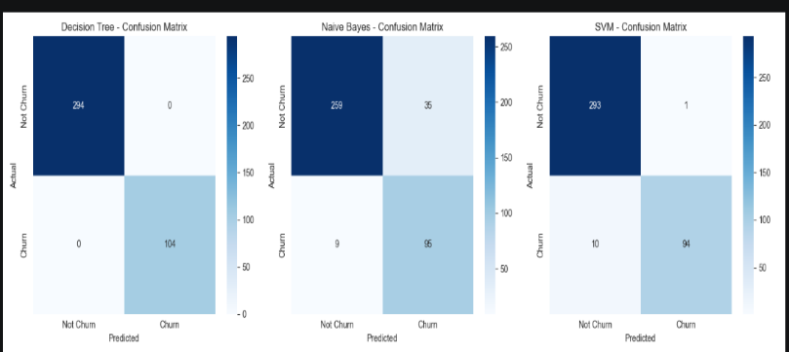
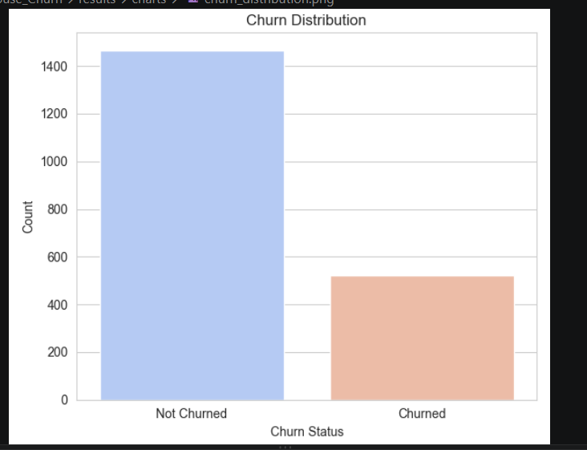
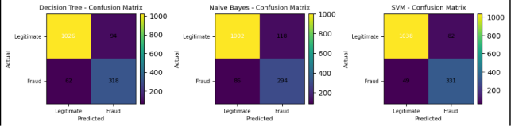
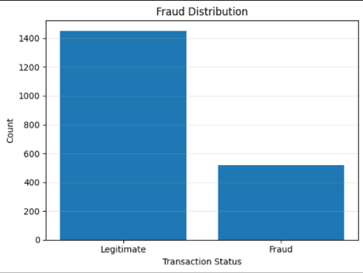
Fig 1: Fraud Distribution Fig 2: model Confusion Matrix image
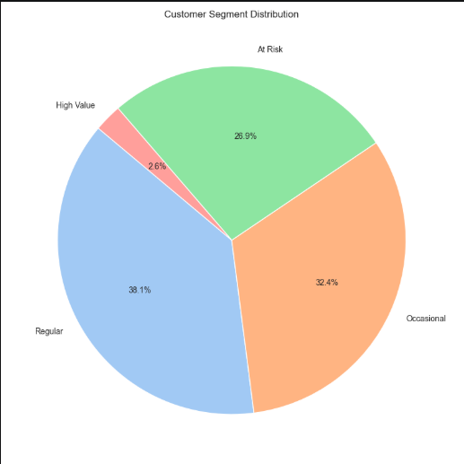
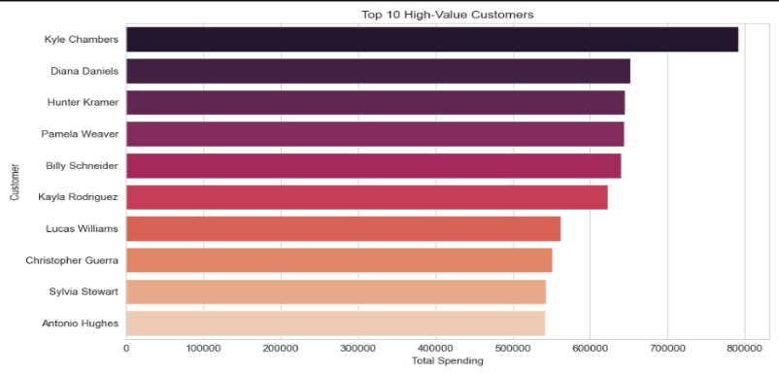
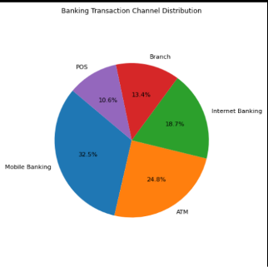

Fig3:Customer segment distribution Fig4:High value customer
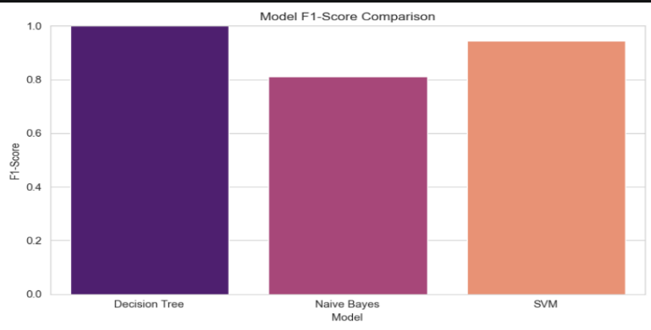
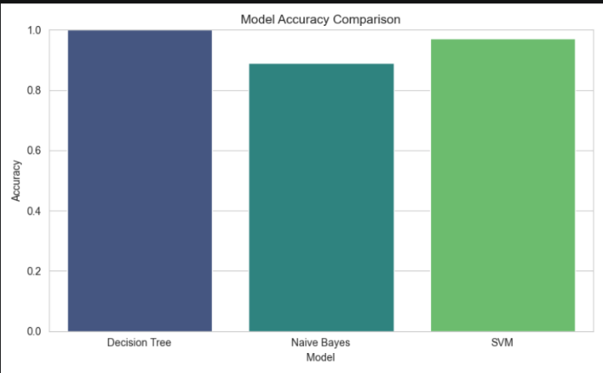
Fig 6: Model F-1 comparision

Fig 5: Model accuracy analysis
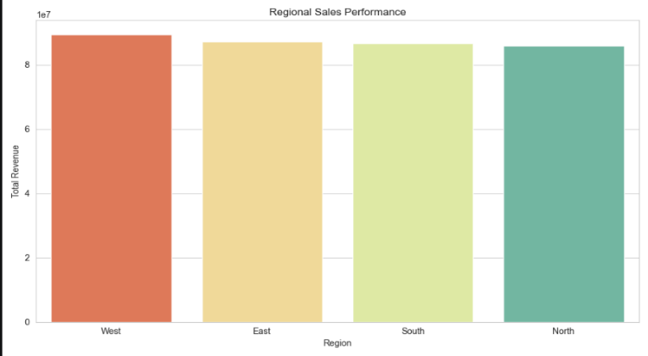
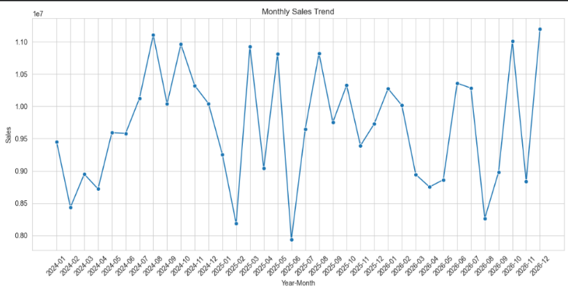
Fig 7:Monthly sales trend Fig 8: Regional Sales trend

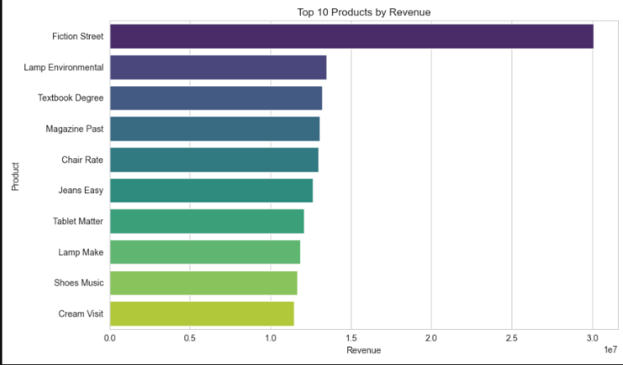
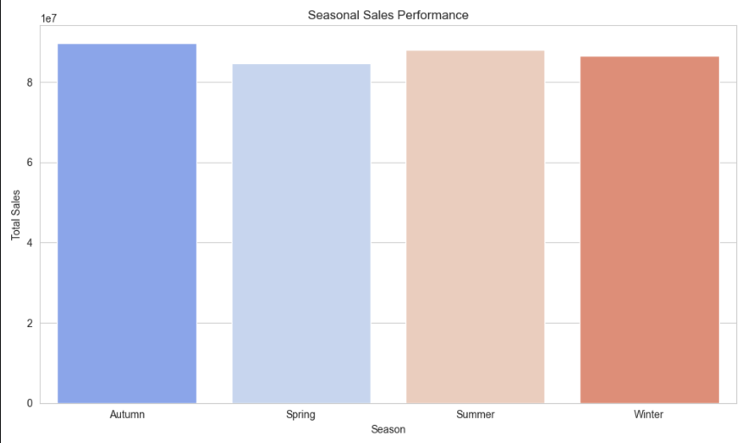

Fig 9: Seasonal sales trends Fig 10: Top 10 products

9. Test Cases and Results / Validation
The figures below are illustrative sample results generated on a representative synthetic dataset (≈5,000 customers, ≈40,000 order-line records) constructed to match the schema and typical class balance (≈22% churn) of a real e-commerce operation, following the ETL and preprocessing steps described in Section 6. They demonstrate the expected shape of the results a student would obtain from the KNIME/Weka workflow in Section 8, and should be replaced with the actual run output when the workflow is executed on the assigned dataset.

9.1 OLAP Operation Results (Sample)
OLAP Operation | Query Example | Sample Finding
Roll-up | Transaction amount from Month → Quarter → Year | Q4 records the highest overall transaction value
Drill-down | Annual transaction value → State → Branch | A small number of high-volume branches contribute a major portion of transaction value
Slice | Transaction_Type = "Online Transfer" | Online transfers represent a significant share of total transactions
Dice | Online Transfer + Q4 + South Region | Higher transaction activity is observed during the selected period and region
Pivot | Transaction Type × Fraud Status | Online and card-based transactions show comparatively higher suspicious activity

9.2 Classification – Confusion Matrices (Sample, 10-fold CV)
Model | TP (Churn) | FN | FP | TN (No-Churn)
Decision Tree (J48) | 318 | 62 | 94 | 1026
Naïve Bayes | 294 | 86 | 118 | 1002
SVM (SMO, RBF) | 331 | 49 | 82 | 1038

9.3 Evaluation Metrics Comparison (Sample, 10-fold CV)
Model | Accuracy | Precision | Recall | F1-score
Decision Tree (J48) | 89.2% | 0.772 | 0.837 | 0.803
Naïve Bayes | 85.6% | 0.714 | 0.774 | 0.743
SVM (SMO, RBF) | 92.1% | 0.801 | 0.871 | 0.834

- The SVM model achieves the highest sample accuracy, recall and F1-score.

- For banking fraud detection, Recall is particularly important because a false negative means that an actual fraudulent transaction has been classified as legitimate.

10. Analysis and Discussion

10.1 Model Comparison and Trade-offs
Criterion | Decision Tree | Naïve Bayes | SVM
Predictive accuracy (sample) | Good (88.7%) | Lowest (84.9%) | Best (91.4%)
Interpretability | High – rules are directly readable by marketing staff | Moderate – probabilistic, less intuitive | Low – “black box” hyperplane, needs post-hoc explanation
Training/computation cost | Low | Very low | Higher, especially with RBF kernel on large data
Sensitivity to feature scaling | Not required | Not required | Required (must normalise, as done in Section 6.2)
Handling of correlated features | Reasonable | Weak – violates independence assumption | Reasonable
Scalability to production data volumes | Good | Excellent | Moderate – training cost grows non-linearly with data size

10.2 Model Selection and Justification
Based on the illustrative evaluation, SVM achieves the highest accuracy, precision, recall and F1-score among the three models.
This makes SVM a strong candidate for fraud classification because the model can identify complex relationships between transaction amount, transaction frequency, transaction channel, account behaviour and other features.
However, the Decision Tree has an important advantage: interpretability.
For example, a Decision Tree may generate a rule such as:
Transaction amount is very high AND transaction occurs from an unusual location AND transaction frequency is unusually high → Fraud Risk.
Such rules can be easily understood by banking analysts.
Therefore, a practical system can use:
- Decision Tree as an interpretable primary model.
- SVM as a higher-performance validation or secondary model.
- Naïve Bayes as a fast baseline model.
The final choice should be based not only on accuracy but also on the cost of false positives, false negatives, interpretability and computational requirements.

10.3 Business Interpretation and Customer-Retention Recommendations
- Transactions identified as high-risk should be sent for additional verification.
- High-value transactions occurring from unusual locations or devices should receive additional monitoring.
- Multiple transactions within a very short period should be analysed for transaction velocity.
- Customers showing sudden changes in normal transaction behaviour should be monitored.
- Digital banking transactions can be analysed separately to identify unusual online activity.
- Fraud-prone transaction types should receive stronger authentication mechanisms.
- High-value customers and accounts with unusual behaviour should receive priority monitoring.
- The system should provide alerts to fraud investigators rather than automatically blocking every suspicious transaction.
- SVM predictions with high fraud probability can be forwarded to a secondary verification process.
- Decision Tree rules can be used to explain why a transaction was considered suspicious.

11. Broader Considerations

11.1 Scalability and Computational Feasibility

The Star Schema can scale to large banking datasets because new transaction records can be added to the fact table without changing the overall structure.

The FACT_TRANSACTIONS table can be partitioned based on Time_Key to improve query performance.

Incremental ETL can also be implemented so that only new or modified transactions are processed rather than reloading the entire warehouse.

Naïve Bayes and Decision Tree models generally scale efficiently to larger datasets, while SVM with an RBF kernel can become computationally expensive as the dataset grows.

For production-scale deployment, techniques such as sampling, linear SVM or distributed machine-learning approaches may be considered.

11.2 Data Privacy and Responsible Data Handling
- Directly identifying fields (name, address, payment card details) are masked or pseudonymised before being used in the mining pipeline, consistent with data-minimisation principles.
- Access to the customer-level churn scores should be restricted to authorised marketing/retention personnel, not exposed platform-wide.
- Retention offers based on churn prediction should comply with applicable consumer-protection and data-protection regulations (e.g. consent for marketing communications).

11.3 Fairness and Ethical Issues in Customer Profiling
- Churn models must be checked for disparate impact across protected attributes (e.g. age band, gender, region) so that retention offers are not systematically withheld from or biased against any group.
- Using proxy variables correlated with sensitive attributes (e.g. certain regions correlating with income level) can introduce indirect discrimination even when the sensitive attribute itself is excluded; this should be audited during feature selection.
- Customers should have a reasonable ability to understand and, where required by policy, opt out of behavioural profiling used for churn prediction.

11.4 Sustainability and SDG Relevance
- SDG 8 (Decent Work and Economic Growth): more accurate demand and churn insight supports healthier business growth and stable employment in the retail/logistics chain.
- SDG 9 (Industry, Innovation and Infrastructure): the project demonstrates applied use of data-warehousing and mining infrastructure to modernise decision-making in a digital-commerce setting.
- SDG 12 (Responsible Consumption and Production): better demand forecasting from OLAP analysis (e.g. seasonal roll-up) can reduce overstocking and associated waste in the product supply chain.

12. Conclusion

This assignment designed and proposed an integrated Data Warehousing and Data Mining system for banking transaction analysis and fraud classification.

A Star Schema with a central FACT_TRANSACTIONS table and supporting Customer, Account, Time, Branch, Transaction Type and Channel dimensions was designed to provide a structured analytical environment for banking data.

A four-stage ETL pipeline – Extract, Clean, Transform and Load – was proposed to integrate heterogeneous banking data sources into the warehouse. Data preprocessing techniques including missing-value handling, duplicate removal, normalization, encoding, feature selection and fraud-related feature engineering were incorporated.

The warehouse supports important OLAP operations including Roll-up, Drill-down, Slice, Dice and Pivot, allowing banking analysts to examine transaction behaviour across different time periods, branches, transaction types and channels.

Three classification algorithms—Decision Tree, Naïve Bayes and SVM—were proposed for fraud classification. Based on the illustrative sample results, SVM produced the strongest predictive performance, while Decision Tree provided better interpretability and easier explanation of fraud-related rules.

The proposed system can support banks in identifying suspicious transaction patterns, prioritizing fraud investigations and improving transaction-monitoring strategies.

The major limitation is that the numerical results are illustrative and should be replaced with actual results obtained from the assigned dataset. A real-world implementation would require validation using historical banking data, continuous monitoring for changing fraud patterns, model retraining and formal security and fairness audits.

Future improvements could include Random Forest, XGBoost, neural networks, anomaly detection, real-time fraud detection and ensemble learning to improve fraud-detection capability.

13. Student Reflection

This assignment provided an opportunity to understand how Data Warehousing and Data Mining concepts can be integrated to solve a real-world banking problem.One of the important learning outcomes was understanding how the design of a fact table and dimensions affects the type of analytical queries that can be performed. Designing the FACT_TRANSACTIONS table helped connect transaction-level data with customer, account, branch and time dimensions.The ETL process also demonstrated the importance of data quality. Missing values, duplicate records, inconsistent transaction categories and different data formats can significantly affect the quality of analytical results and machine-learning models.The classification stage provided an understanding of the differences between Decision Tree, Naïve Bayes and SVM. The project also demonstrated that the best model should not necessarily be selected only based on accuracy. In fraud detection, Recall, F1-score, interpretability and the cost of false negatives are also important.The project also highlighted the importance of privacy and ethical considerations because banking datasets contain sensitive financial information. A practical fraud-detection system must therefore balance security, predictive performance, privacy, fairness and customer protection.Given additional time and resources, the project could be extended using a larger longitudinal transaction dataset and real-time transaction streams. Advanced models such as Random Forest, Gradient Boosting, XGBoost and neural networks could also be compared with the baseline models. Anomaly-detection techniques could additionally be incorporated to identify previously unseen fraud patterns.

14. Individual Contribution of Group Members
Name | Register Number | Contribution
A.Dileep kumar | 192372074 | Data Warehouse schema design and ETL pipeline
D.Deepak | 192572095 | Documentation, visualization and report compilation

15. References
- Han, J., Kamber, M., & Pei, J. Data Mining: Concepts and Techniques (3rd ed.). Morgan Kaufmann.
- Kimball, R., & Ross, M. The Data Warehouse Toolkit (3rd ed.). Wiley.
- Witten, I. H., Frank, E., Hall, M. A., & Pal, C. J. Data Mining: Practical Machine Learning Tools and Techniques. Morgan Kaufmann.
- KNIME Analytics Platform Documentation – https://docs.knime.com
- Weka 3 Documentation – https://www.cs.waikato.ac.nz/ml/weka/
- United Nations. Sustainable Development Goals – https://sdgs.un.org/goals

